## S.5.3 Alpha diversity heatmaps

*Figure S.5.3.1: heatmaps showing alpha diversity at the cell level in the Natura 2000 landscape. The different maps represent different temperature scenarios: (a) 12.01 °C (b) 13.35 °C (c) 15.05 °C. Darker colours indicate higher diversity.*

*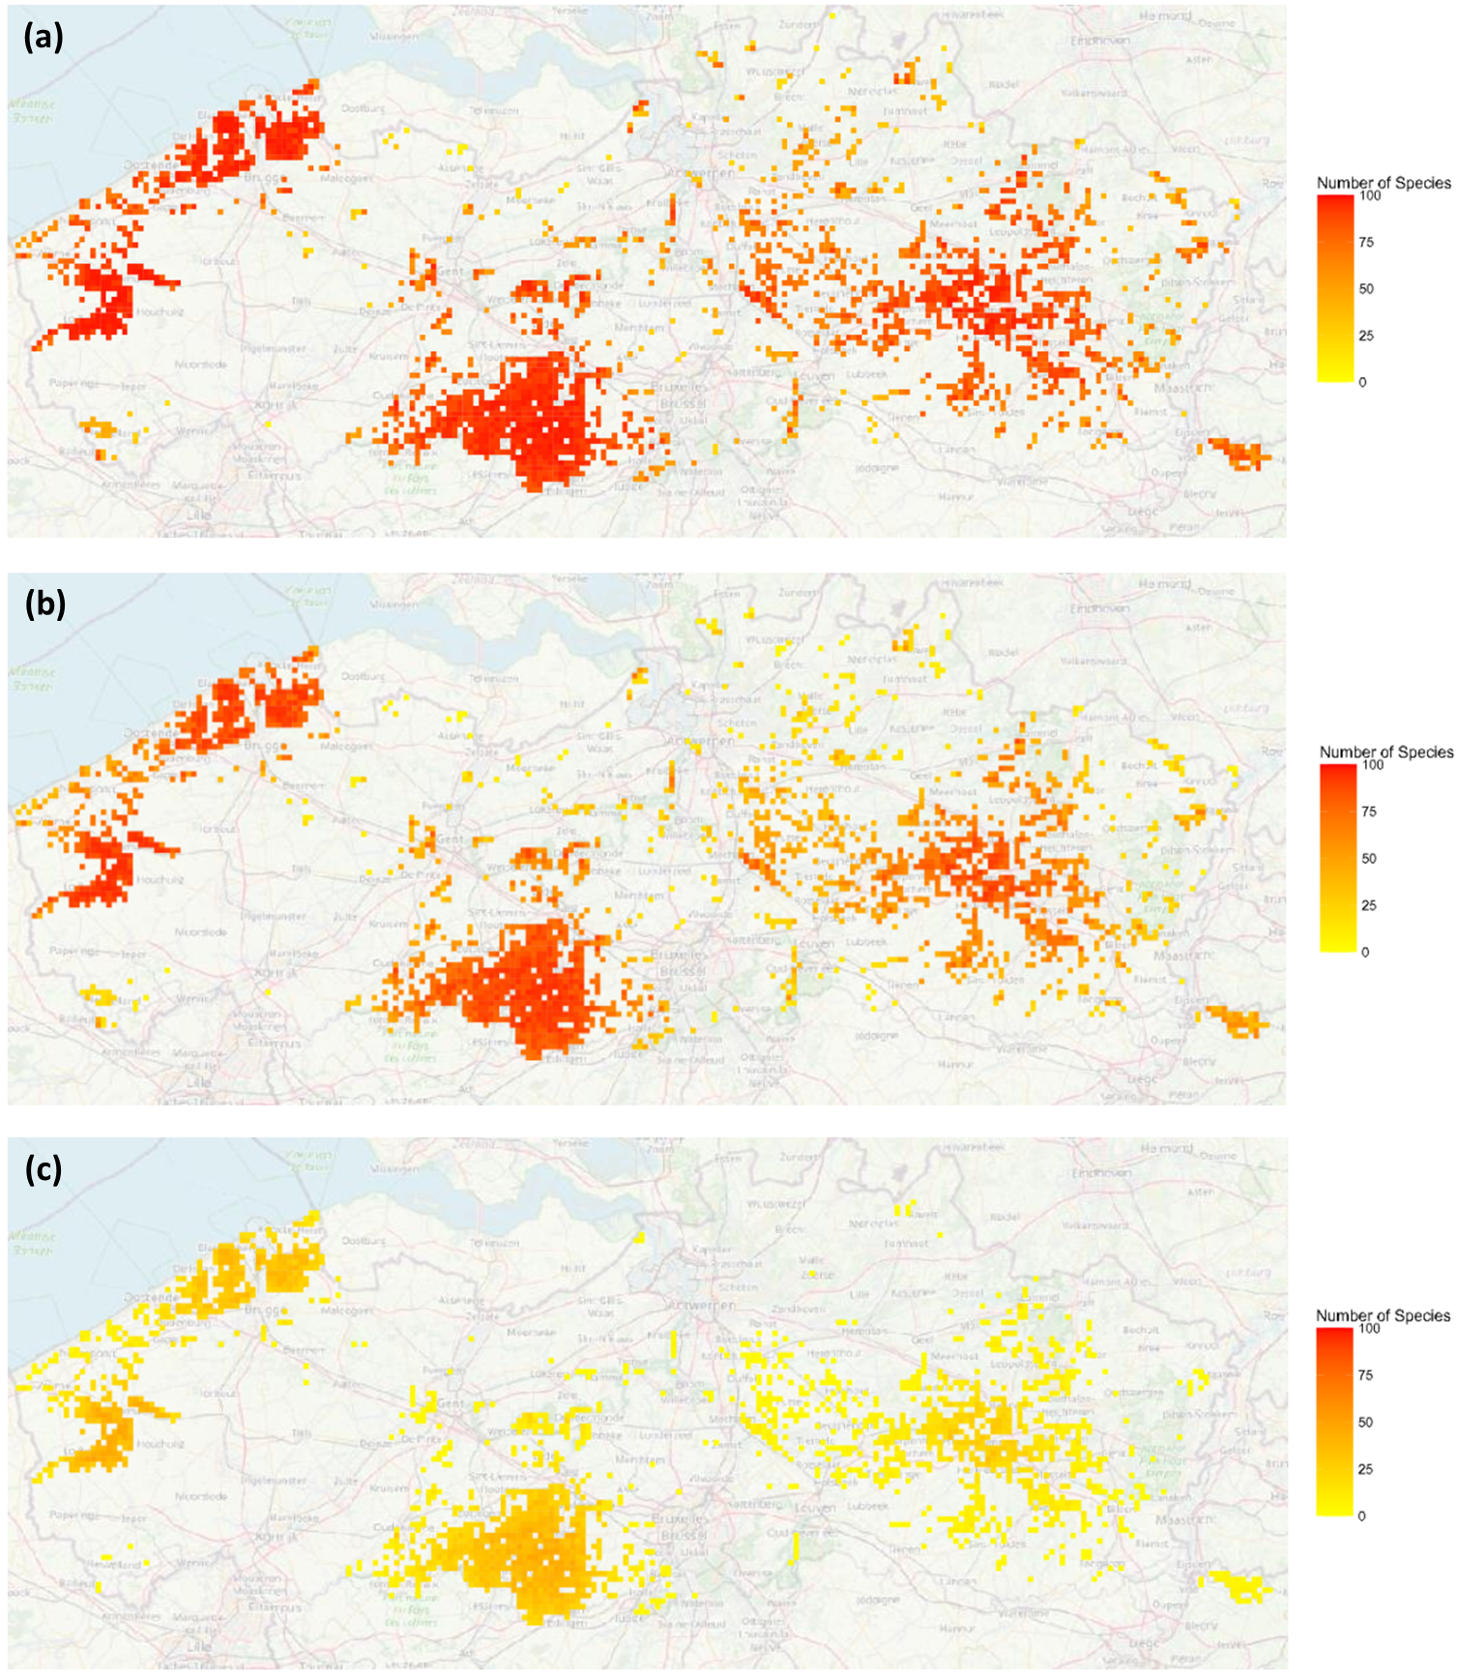Figure S.5.3.2: heatmaps showing alpha diversity at the cell level in the all grasslands landscape. The different maps represent different temperature scenarios: (a) 12.01 °C (b) 13.35 °C (c) 15.05 °C. Darker colours indicate higher diversity.*